ROTARY DISTRICT 6220
GLOBAL GRANT SCHOLARS TESTIMONIALS
(October 2023)

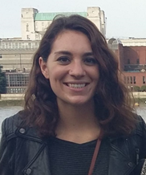
Tracy Wilichowski (2014-2015)
GGS Rotary Area of Focus: Economic and Community Development
Place of Study: London School of Economics, London, United Kingdom
Studies & Degree: Master in Development Studies
UPDATES
From January to June 2017, I worked as a consultant for The World Bank Group in Washington, DC. As part of my role in the Education Global Practice, I support both analytical and operational activities related to teacher practices and behavior, basic education, and service delivery in developing countries. Specifically, I aid in coordination and application of Systems Approach for Better Education Results (SABER) tools. SABER uses diagnostic tools and detailed policy information to collect and analyze comparative data and knowledge on education systems around the world, highlighting the policies and institutions that matter most to better promote learning for all children and youth. Currently, I assist clients on projects in Tanzania, Romania, Afghanistan, Uruguay, and Punjab, Pakistan.

Since July 2017, I've transitioned to a staff position where I provide analytical support to the Director of the Education Global Practice. I assist in coordination of high-level global education events through conceptualization; internal and external communications; preparation of event materials, briefs, and logistics; and day-of support. I also manage relationships with key partners by assisting in coordination of in-person meetings, preparation of briefing materials and presentations for senior management, and representation of World Bank Group at partner events. In this capacity, I prepare, coordinate, and edit inputs for education publications, including research papers, blogs, presentations, and issue briefs.

As part of my role, I’m also involved in the development and oversight of an open source classroom observation tool, designed to capture what’s happening in classrooms around the world. This tool was created to capture how teachers develop students’ social and emotional skills in addition to standard pedagogic instructional practices in developing countries. The tool is free, open-source, and can be easily adopted in different contexts with no intellectual property restraints. It is intended to be used by researchers, as well as principals, pedagogical advisors, coaches, and inspectors across a variety of settings. Thus far, I have helped oversee the implementation of the tool in the Philippines, Uruguay, Pakistan, Afghanistan, and Mozambique.

In May 2018 Sarah was one six past scholars and Peace Fellows who were invited and presented at the 2018 TriCon Annual Conference which was an annual meeting for three Rotary Districts (6220, 6250 & 6270).

Tracy was invited to the featured luncheon speaker at the June 8, 2019 District 6270 Annual Conference in La Crosse, Wi. The following is a YouTube video of her presentation: https://youtu.be/W7U9gE2TiEs

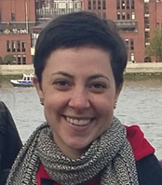
Nicole Ostrand (2015-2016)
GGS Rotary Area of Focus: Peace and Conflict Prevention/Resolution
Place of Study: University of Sussex, Brighton, United Kingdom
Studies & Degree: Doctorate in Migration Studies

I am passionate about helping people, I always have been. Over the last six years I become especially interested in migrant and refugee issues. I am committed to empowering and promoting the rights of migrant and refugee populations around the globe. This is a particularly salient issue in the current political climate where fear and prejudices are rampant. It is more important than ever to provide thoughtful and humane analyses on how to ensure the basic security and rights of migrants and refugees are protected.
The Rotary International Global Grant Scholarship from District 6220 has given me the opportunity to pursue what I love and further my career dedicated to migrants and refugees. With this scholarship, I was able to start my doctorate degree in migration studies at the University of Sussex in the United Kingdom. This has provided me with countless opportunities to engage with and think critically about this topic. At the University of Sussex, I have had access to academics, seminars, conferences, courses and volunteer groups concerned with these issues. Being a Global Grant Scholar has also given me the opportunity to meet with former and current Rotary Scholars. This has been particularly fulfilling as it has allowed me to forge new relationships and share interests and experiences.
I truly love what I do, and I could not be happier to be where I am today. Getting doctorate degree is a blessing. The Global Grant Scholarship has been a tremendous support in helping me follow this dream.
UPDATE
Status (2022): I am currently living in Oslo, Norway. I moved here at the end of February for a 2-year postdoctoral research position. I'm focusing on EU deportation practices.

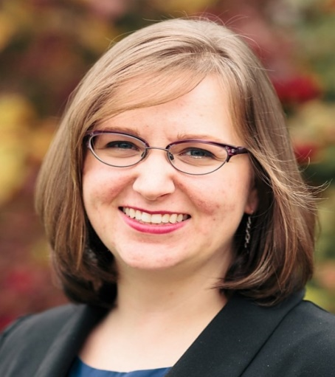
Paula K. Priebe (2017-2018)
GGS Rotary Area of Focus: Peace and Conflict Prevention/Resolution
Place of Study: University for Peace; Cuidad Colon, San Jose, Costa Rica
Studies & Degree: Master of Arts in International Peace Studies

My background is in Urban Planning and international volunteering. However, I was feeling the desire to go back to school and shift my career focus. That can be challenging; leaving a career to pursue something different. However, working with Rotary, I am supported in my endeavors and have the financial freedom to take time to return to school. It has also been a blessing to have the comradeship of two fellow Global Grant scholars at my school and the support of a local Rotary Club here in Costa Rica.
The Rotary area of focus of my Global Grant is Peace and Conflict Prevention/Resolution. It aligns very closely with my chosen degree program. I hope to work in the field of post-conflict redevelopment after I complete my studies at UPeace, blending my background as an urban planner with my new focus of international peace studies.
UPDATE
Paula completed her study abroad at the University for Peace, San Jose, Costa Rica, supported by her Global Grant Scholarship.

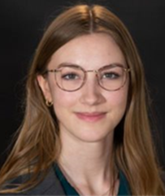
Anna K. DeWitt (2019-2020)
GGS Rotary Area of Focus: Peace and Conflict Prevention/Resolution
Place of Study: Queen’s University Belfast, Northern Ireland, United Kingdom
Studies & Degree: Master of Arts in Conflict Transformation and Social Justice

Anna K. DeWitt completed her graduate program in 2020 and extended stay volunteer and part time work in 2021. She returned to her hometown of Appleton, WI, in the spring of 2021.

UPDATE
I am working at Global Minnesota, a non-profit, non-partisan organization based in the Twin Cities. Global Minnesota's mission is to advance international understanding and engagement. As a part of this mission, my role works with international students studying in Minnesota. My goal is to help international students feel welcomed and connected in our community, as well as support opportunities for exchange with Americans. One of my favorite parts of my role is supporting Global Minnesota's Classroom Connection program. This program involves international student volunteers visiting elementary and middle school classrooms to share information about their cultures and countries. It's great to see young Minnesotans learning about new places and ways of life and overcoming cultural stereotypes to form a better understanding and respect for others.

In addition to working, I am also in the process of deciding on a local Rotary Club to join. The Minnesota University Rotary Club has invited me to join them, and I was able to attend one of their meetings last week. They've invited me to speak about my experience as a GGS at one of their upcoming meetings, too. I'm looking forward to maintaining my connection with Rotary! As always, I am very grateful for my experience as a GGS and hope to continue finding new ways to pay it forward.

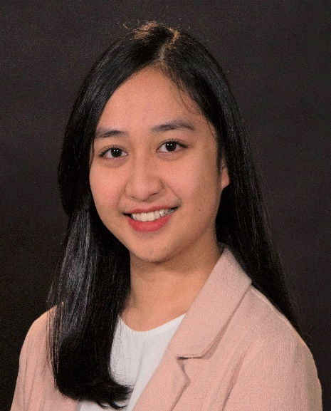
Keyla V. Higa (2020-2021)
GGS Rotary Area of Focus: Peace and Conflict Prevention/Resolution
Place of Study: Erasmus University Rotterdam, Rotterdam, The Netherlands
Studies & Degree: Master of Science in Governance of Migration & Diversity

I currently work as a teaching fellow at KIPP Massachusetts Elementary School in Lynn, MA, an organization that I joined last year. While I am juggling my full-time job, completing my graduate program, and personal life, I am determined to be present and take full responsibility for all of them, even though it takes me some extra time to do so.
My current role as a teaching fellow, working with kindergarteners, is a detour from what I had planned when I graduated from Lawrence University in 2020 and when I became a part of Rotary. I had thought that I'd work at a nonprofit and do policy research and analysis as that is what I learned throughout my graduate program so that in the long run I can build a career path towards working at the United Nations. However, as a teaching fellow, I'm learning about the art of teaching and inclusive curriculum for all types of students. While I'm shaping young minds to be conscious about the diversity of their surroundings, I also believe that I am still contributing bits and pieces towards my area of focus of peacebuilding in the long run.

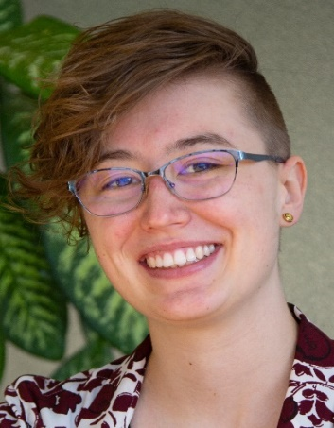
Sanne M. Roeven (2021-2022)
GGS Rotary Area of Focus: Peacebuilding and Conflict Prevention
Place of Study: London School of Economics, London, England
Studies & Degree: MSc in Human Rights (focus on gender and forced migration in the human rights field)

Sanne completed her year-long master’s in Human Rights and received approval for her dissertation “Navigating Complexity: The Afghan diaspora’s experiences in London” at the end of August. In her research Sanne conducted a thematic analysis of 3.5 years of mixed media sources produced by London Afghans, coming up with three key areas of concern: Relationship with Afghanistan, Transnational Family and Kinship Networks, and Mental Health. Her article, “Existence Reframed: Wij Zijn Hier and resisting colonial systems of erasure,” was published in the LSESU Amnesty International Society’s 8th Edition of their Beacon Journal Power and Resistance. She is now looking to enter the field of human rights, refugee rights, and LGBTQ rights in London, and is particularly interested in roles related to research, communications, and volunteer coordination.
UPDATE
Early in January 2022 Istarted my new job as an immigration link worker for the London homelessness charity St Mungos in the London area. It's been a huge learning curve, but I'm really enjoying it.

Sophie J Buchholz (2022-2023)
GGS Rotary Area of Focus: Environment
Place of Study: Memorial University of Newfoundland, Grenfell Campus, Corner Brook, NL, Canada
Studies & Degree: Master of Arts in Environmental Policy with a focus on expertise in climate adaptation

It’s been about four months since I’ve arrived in Corner Brook in September 2022, and I’ve completed my first semester and beginning my 2nd at this time! So far in my coursework I’ve obtained a great amount of knowledge on how I will conduct my research thesis, which will be useful as I start my thesis project in the upcoming months. I’m really looking forward to taking my first research trip up to Labrador in a few weeks, where I will be introduced to the community of Cartwright, where I’ll be working with for my thesis project. The town of Corner Brook is quite small compared to most places I’ve lived, but I’m starting to adjust to the different style of living that occurs here. I feel quite lucky to have visited the nearby Gros Morne National Park twice, and I can’t wait to travel more throughout the province and develop a relationship with Corner Brook Rotary in my two years here.

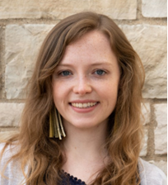
Alexandra Freeman (2023-2024)
GGS Rotary Area of Focus: Peacebuilding and Conflict Prevention
Place of Study: London School of Economics, London, England
Studies & Degree: Master of Science in Global Media and Communications

UPDATE
I had my first meeting with my host Rotary Club on September 20, when I came to their “philosophy cocktail hour” – a social event where a facilitator encouraged the group to debate philosophical questions like “why is swearing seen as wrong?” and “do we dress more for ourselves or for others?” Philosophy isn’t usually my thing, but I actually thought some of the discussions were really interesting, and everyone in the club was incredibly welcoming.
Compared to Rotary clubs I’ve seen in Appleton and Kansas City, the Rotary Club of Mayfair is clearly a newer club, with younger members overall. Most of the club members I met were under 50, which is fairly uncommon for Rotary. As such an established organization, it makes sense that membership skews older, but it was refreshing to see some younger perspectives represented.
In order to get a better sense of what the next generation of Rotary looks like, some of the Mayfair members encouraged me to get involved in Rotaract, which is the branch of Rotary designed for 18-30-year-olds. There are several Rotaract clubs in London and tons of clubs around Europe – and, as luck would have it, the annual European Rotaract conference was scheduled for October 5-7 in Stockholm, and I was invited to join as part of the UK delegation. So I booked a plane ticket to Sweden, and off I went!
I just got back from the conference today, so I’m still processing everything (and also feeling exhausted from a jam-packed weekend), but I’m really glad I decided to go, even if it was a little last minute. While you’re inevitably going to get some diversity of opinion and values when you gather 400+ people from different countries, it was exciting to be around so many other young people who are invested in global engagement and cooperation. In addition to representatives from nearly every European country, there were also a few Rotaracters from North Africa, Latin America, and even a few other American transplants to Europe who I met at the conference! I’m hoping to find a Rotaract Club in London within the next few weeks – there are two clubs who have invited me to attend one of their meetings, it’s just a matter of figuring out my schedule.
You can read more of Alex’s updates on her blog: https://alexkfreemanblog.wordpress.com/.

